Stereo

Mengyun Xia

*EECE 5639, Computer Vision*

*April 27, 2016*

**Abstract**

In this project, we will find corners in two images and estimate the Fundamental Matrix and use RANSAC to eliminate outliers. Finally, we will compute a dense disparity map using the Fundamental matrix to help reduce the search space.

# Introduction

The ability to infer information on the 3D structure and distance of a scene from two or more images taken from different viewpoints. Stereo Vision Problems: Correspondence Problem: Determining which pixel on the left corresponds to which pixel on the right. Reconstruction Problem: Given a number of correspondence pairs and camera geometry information, find location and 3D structure of the observed objects. Fundamental Matrix Properties has rank 2 and depends on the intrinsic and extrinsic parameters. The fundamental matrix also tells how points in each image are related to epipolar lines in the other image.

1. **Description of Algorithms**
2. Read in two images and make them grayscale.
3. Apply Harris corner detector to both images: compute Harris R function over the image, and then do non-maximum suppression to get a sparse set of corner features.
4. Given two set of corners from the two images, compute normalized cross correlation (NCC) of image patches centered at each corner. Choose potential corner matches by finding pair of corners (one from each image) such that they have the highest NCC value. Then set a threshold to keep only matches that have a large NCC score to find correspondences between the two images.

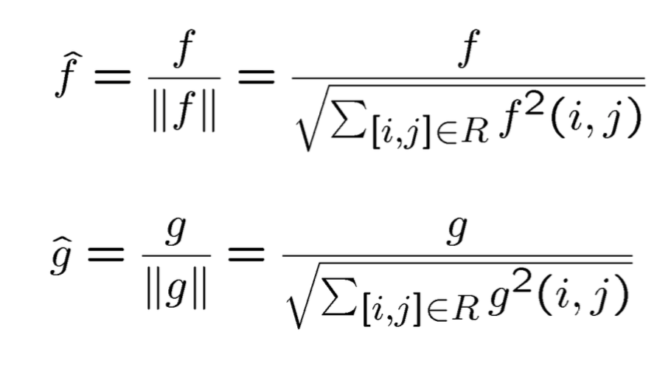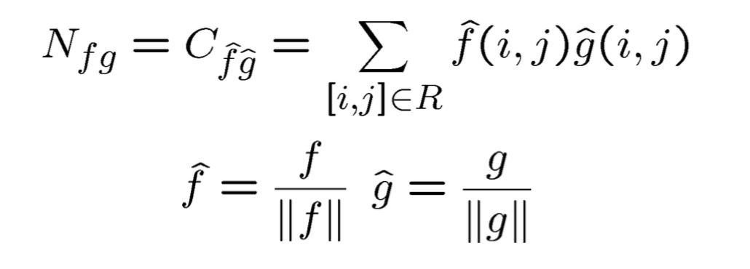

1. Estimate the Fundamental Matrix for each pair using the correspondences above and RANSAC to eliminate outliers.

Fundamental Matrix：

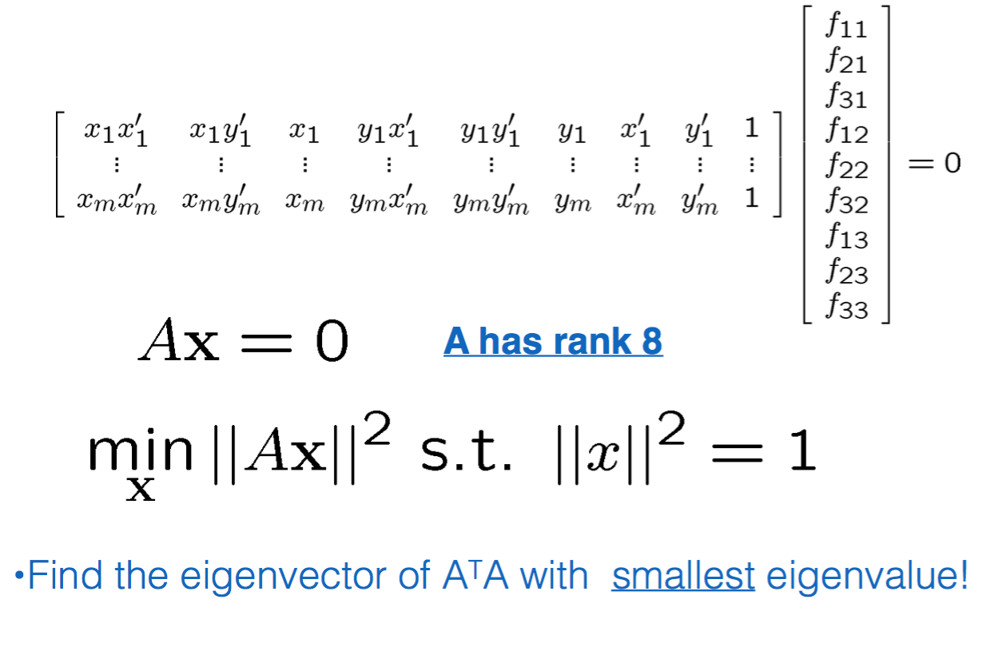

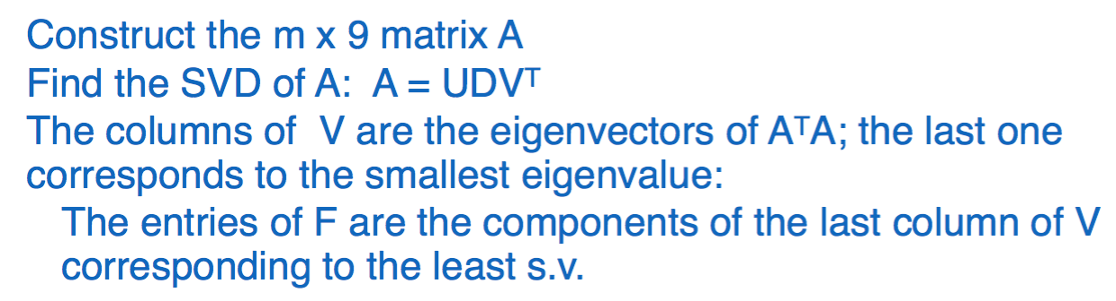

RANSAC:

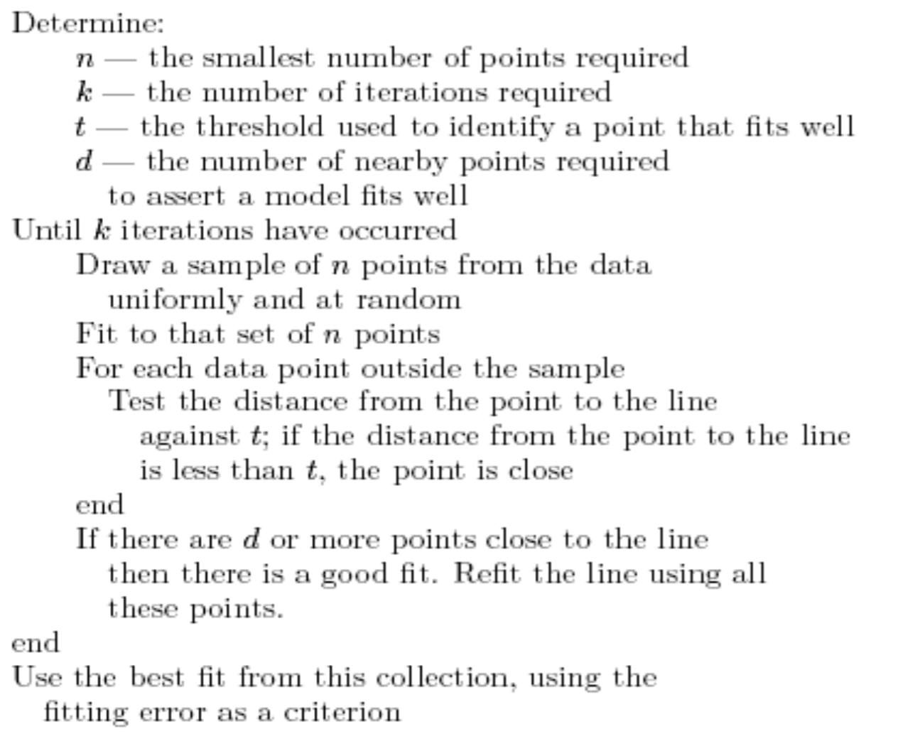

1. Compute a dense disparity map using the Fundamental matrix to help reduce the search space.

CORR_MATCHING Algorithm :

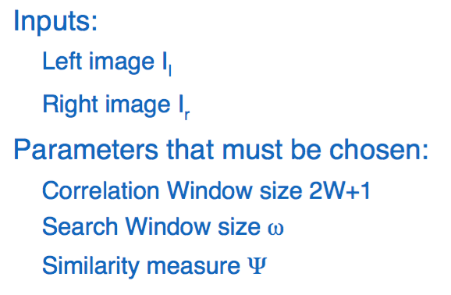

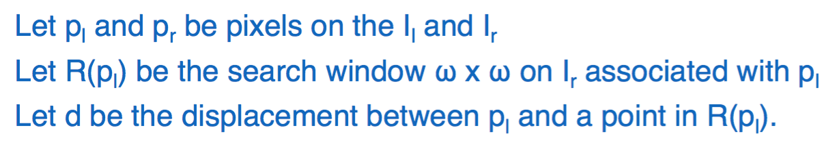

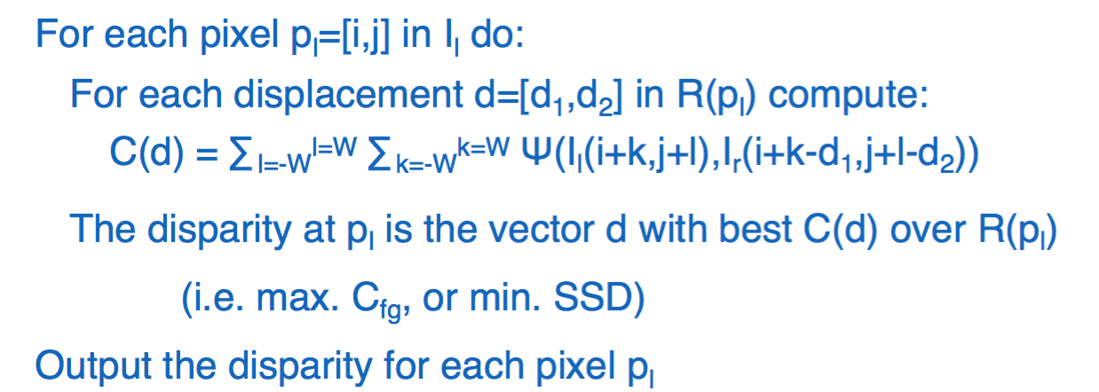

1. **Experiments and values of parameters used**
2. Read in two images and make them grayscale.
3. Find interesting features and correspondences between the left and right images.

Gaussian filter: sigma=1.4, range from -3 to 3. Harris R function: kappa=0.04

NCC: thresholding=0.9

1. Estimate the Fundamental Matrix for each pair using the correspondences above and RANSAC to eliminate outliers.

RANSAC: cycles=1000

1. Compute a dense disparity map using the Fundamental matrix to help reduce the search space. The output should be two images, one image with the vertical disparity component, and another image with the horizontal disparity component. Scale the gray values so the lowest disparity is 0 and the highest disparity is 255.
2. **Observations**

The program also uses other images as the samples.

1. **Conclusion**

Using Harris corner detector can detect a large number of corners. After using NCC to find correspondence between the two images, the correspondences are likely to have many errors. Using RANSAC can robustly estimate the homography from the noisy correspondences. Warping the image into the output image based on the inverse of the estimated homography can have no gaps. It is a good way to produce an image mosaic.

1. **Appendix**